Supplementary information for

A longer time to relapse is associated with a larger increase in differences between paired primary and recurrent IDH wild-type glioblastomas at both the transcriptomic and genomic levels

Wei-Min Ho, Chia-Ying Chen, Tai-Wei Chiang, and Trees-Juen Chuang*
* Correspondence: trees@gate.sinica.edu.tw

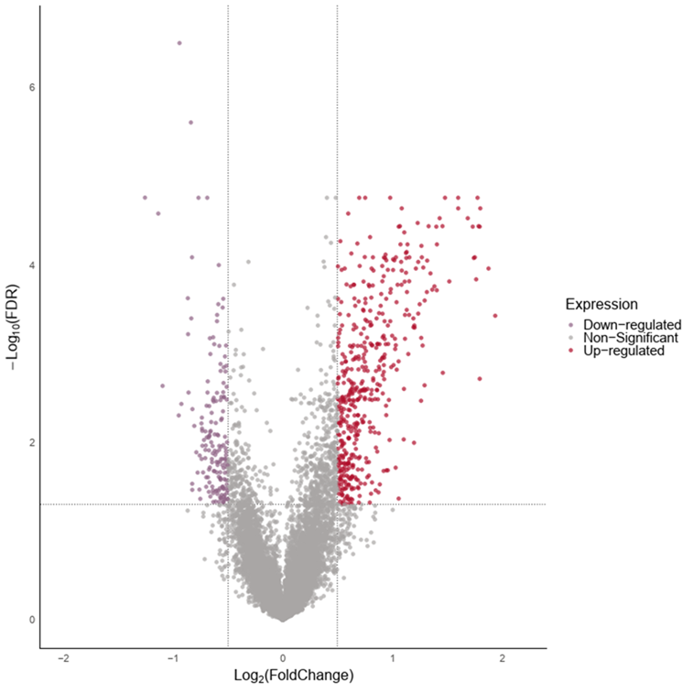
Figure S1. Differential expression of genes in primary and recurrent GBM pairs from the GLASS Cohort.

The volcano plot displays the differentially expressed genes identified in paired primary and recurrent glioblastoma multiforme samples from the GLASS cohort. The x-axis represents the log2 fold change in gene expression between recurrent and primary GBM pairs, while the y-axis represents the -log10 of the false discovery rate, indicating the significance of differential expression. Up-regulated genes are shown as red dots on the right side of the plot. Down-regulated genes are represented by purple dots on the left side. Genes with non-significant differential expression are shown in gray.

Figure S2. Correlation between paired primary and recurrent GBMs in gene expression profiles based on the single-cell RNA-seq data. The orange and blue solid dots represented the cases with a long TTR and a short TTR (median of TTR = 301 days), respectively. Numbers in parentheses indicated the fitting levels (measured by the RSEM) of the cases in the three TTR groups. Correlation coefficient and P value were evaluated using the Pearson’s correlation analysis. pGBM, primary GBM. rGBM, recurrent GBM.

Figure S3. Kaplan-Meier analysis of the seven key genes (SIGLEC14, GHRHR, TAS2R1, CDKL1, ZSCAN10, TBX15, and CD101) in the GLASS dataset. P values were evaluated using log-rank test.

Figure S4. Calibration curves for predicting TTR at one and two years for the primary IDH-wildtype GBM patients. The curve for predicting TTR at three years was not plotted because of the small sample size for the patients with TTR > 3 years.

Figure S4. Comparisons of the TMB values (mutations/Mb) among the patients in the three TTR groups (TTR ≤ 6 months, TTR of 7-12 months, and TTR < 12 months) for primary and recurrent GBM samples. P values were evaluated using two-tailed Wilcoxon rank-sum test. pGBM, primary GBM. rGBM, recurrent GBM. *, P ≤ 0.05. **, P ≤ 0.01. ns, not significant.

Figure S5. Correlation between the PC1s of genes expressed in paired primary and recurrent GBMs (n=16) for the GBM dataset generated by Korber et al. (Korber V, et al. Evolutionary Trajectories of IDH(WT) Glioblastomas Reveal a Common Path of Early Tumorigenesis Instigated Years ahead of Initial Diagnosis. Cancer Cell 35, 692-704 e612 (2019)) Correlation coefficients and P values were evaluated using the Pearson’s correlation analysis. pGBM, primary GBM. rGBM, recurrent GBM.

Figure S6. Comparison of the risk scores (based on the constructed model, Model-ours) of the patients in the two molecular groups illustrated in Figure 5 (Group 1 with 39 cases and Group 2 with 48 cases). P value was evaluated using two-tailed Wilcoxon rank-sum test.

Figure S7. Assessment of the predictive power of the two prognostic models, Model-new1 and Model-new2, in the training set (the GLASS cohort) and two testing sets (the TCGA and G-SAM cohorts). A The key genes identified by the multivariate Cox regression analyses for Model-new1. B-D Kaplan-Meier analyses of the progression-free survival for the two groups segregated by Model-new1 in the primary GBM samples of the GLASS (n = 87), TCGA (n = 109), and G-SAM (n=155) cohorts, respectively. E The key genes identified by the multivariate Cox regression analyses for Model-new2. F-H Kaplan-Meier analyses of the progression-free survival for the two groups segregated by Model-new2 in the primary GBM samples of the GLASS (n = 87), TCGA (n = 109), and G-SAM (n=155) cohorts, respectively. G Comparison of the concordance indices (C-indices) of Model-ours, Model-new1, and Model-new2. All P values were evaluated using log-rank test. Coef., coefficient. HR, hazard ratio.

Figure S8. The risk scores (based on the constructed prognostic model for PFS) of the mesenchymal, proneural, and classical subtypes of the primary GBMs in the GLASS dataset. P values were evaluated using two-tailed Wilcoxon rank-sum test.

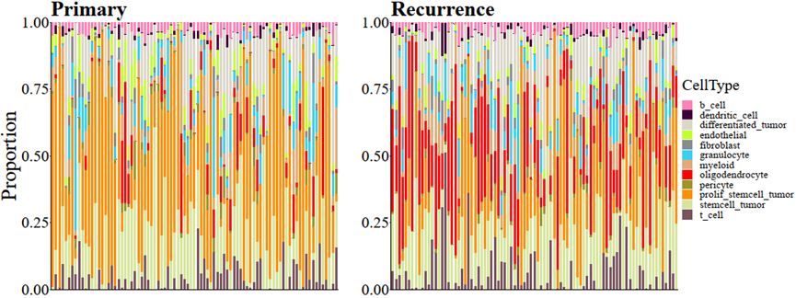
Figure S9. Cell-state distribution across individual primary and recurrent GBM Samples. The stacked bar plots show the proportional distribution of various cell states across individual samples of pGBM (left panel) and rGBM (right panel). Each vertical bar represents a single tumor sample, with different colors indicating the relative abundance of specific cell states. The plots highlight the heterogeneity between pGBM and rGBM, suggesting diverse cellular dynamics at different stages of disease progression. Each sample exhibits a unique cellular composition, contributing to the variability in GBM pathology. GBM, Glioblastoma multiforme. pGBM, primary GBM. rGBM, recurrent GBM.

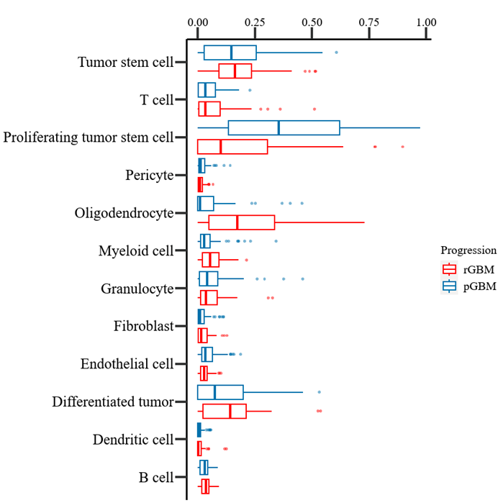
Figure S10. Cell-state comparison between primary and recurrent IDH-wildtype GBM samples. The boxplot displays the relative proportions of the 12 cell states in pGBM (blue) versus rGBM (red). Each boxplot represents the distribution of cell state proportion as a percentage within tumor samples. The x-axis represents the percentage of each cell states, ranging from 0 to 1. The y-axis lists different cell states. Proliferating tumor stem cells and oligodendrocytes exhibit a higher proportion in recurrent GBM, indicating shifts in cellular state during progression. Tumor stem cells show a similar distribution in both initial and recurrent GBM, with relatively high proportions in both cases. Myeloid cells and differentiated tumor cells are also consistently present in both initial and recurrent stages, though with a slightly reduced presence in the recurrent samples. T cells, granulocytes, pericytes, dendritic cells, endothelial cells, fibroblasts, and B cells are present at lower percentages, with minimal variation between initial and recurrent tumors. GBM, Glioblastoma multiforme. pGBM, primary GBM. rGBM, recurrent GBM.

Figure S11. Cell-state compositions of primary and recurrent IDH-wildtype GBM samples with TTR ≤ 6 months, TTR of 7-12 months, and TTR < 12 months. P values were evaluated using two-tailed Wilcoxon rank-sum test.

Codes

### Codes for STAR and RSEM
#!/bin/zsh
cat Sample.list | while read line
do
echo $line
samtools sort -n -o /path to the sorted .bam files/$line.sorted.bam -@ 10 /path to the .bam files/$line.bam
samtools fastq -1 /path to fastq files/$line.R1.fastq.gz -2 / path to fastq files /$line.R2.fastq.gz -0 /dev/null -s /dev/null -n -@ 10 / path to the sorted .bam files /$line.sorted.bam

/home/treeslab-pc8/anaconda3/bin/STAR \
--runThreadN 10 \
--genomeDir /path to STAR directory/STAR_index_human_with_anno \
--readFilesIn / path to fastq files /$line.R1.fastq.gz / path to fastq files /$line.R2.fastq.gz \
--readFilesCommand zcat \
--outFileNamePrefix /path to store STAR files/ \
--outSAMtype BAM Unsorted \
--outSAMunmapped Within KeepPairs \
--outReadsUnmapped Fastx \
--quantMode TranscriptomeSAM GeneCounts

/home/treeslab-pc8/anaconda3/bin/rsem-calculate-expression -p 10 --paired-end --bam '/path to STAR files/Aligned.toTranscriptome.out.bam' /path to STAR_RSEM_index/RSEMIndex /path to store RSEM files/$line.RSEMExp

done

